

Procurement Management Process ©
For [Project Name]

Document Control

Document Information
© | Information
Document Id | [Document Management System #]
Document Owner | [Owner Name]
Issue Date | [Date]
Last Saved Date | [Date]
File Name | [Name]

Document History
Version | Issue Date | Changes
[1.0] | [Date] | [Section, Page(s) and Text Revised]

Document Approvals
Role | Name | Signature© | Date
Project Sponsor

Project Review Group

Project Manager©

Quality Manager
(if applicable)

Procurement Manager
(if applicable)

Communications Manager
(if applicable)

Project Office Manager
(if applicable)

Table of Contents

Template Guide 1
1 Procurement Process 2
1.1 Overview 2
1.2 Issue Purchase Order 3
1.2.1 Identify Required Product 3
1.2.2 Document Purchase Order 4
1.2.3 Approve Purchase Order 4
1.2.4 Issue Purchase Order to Supplier 4
1.2.5 Communicate Delivery Timeframes 4
1.3 Fulfil Purchase Order 4
1.3.1 Receive Product 4
1.3.2 Review Product 5
1.3.3 Resolve Product Issues 5
1.3.4 Accept Product 5
1.3.5 Approve Payment 5
1.4 Manage Supplier Contract 5
1.4.1 Confirm Milestone Reached 5
1.4.2 Review Supplier Performance 5
1.4.3 Identify Supplier Issues 6
1.4.4 Resolve Supplier Issues 6
1.4.5 Communicate Review Outcome 6
2 Procurement Roles 6
2.1 Procurement Manager / Officer 6
2.2 Project Manager 6
3 Procurement Documents 7
3.1 Procurement Register 7
3.2 Purchase Order Form 7

Template Guide

What is a Procurement Management Process?

A Procurement Management Process is a formal method by which products (goods or services) are acquired for a project from external suppliers. The process entails managing the ordering, receipt, review and approval of products from suppliers, as well as the overall management of supplier relationships to ensure continued customer service.

A Procurement Management Process is used to ensure that all products acquired for the project are in accordance with the requirements set out by the Procurement Plan. This requires that the products are:

- Acquired within the correct timescales
- To the level of quality defined
- Within the budgeted cost identified. ©

The process also lays out the procedures for ensuring that supplier relationships are properly managed through the:

- Regular review of supplier performance
- Identification and resolution of supplier issues.

When to use a Procurement Management Process

The Procurement Management Process is initiated immediately after the Procurement Plan has been approved and the Supplier Contract signed (i.e. during the ‘Execution’ phase of the project). The Procurement Process is usually managed by a single resource within the project (usually a Procurement Officer or Manager) and overseen by the Project Manager.

Without a formal Procurement Management Process in place it will be difficult to confirm that the products provided by the supplier are ‘fit for purpose’ and hence meet the requirements outlined within the Procurement Plan. Furthermore, it will be difficult to identify and manage supplier issues and will therefore increase the overall risk to the project. The Procurement Management Process is terminated only when the Execution phase of the project is completed (i.e. just prior to Project Closure). ©

How to use this template
This document provides a guide on the topics usually included in a Procurement Management Process. Sections may be added, removed or redefined at your leisure to meet your particular business circumstance. Example tables, diagrams and charts have been added (where suitable) to provide further guidance on how to complete each relevant section.

Procurement Process

Overview

Provide an overview of the Procurement Management Process. For example:

"The Procurement Management Process is undertaken to ensure that all products (i.e. goods and services) are ordered, delivered and received in accordance with the Procurement Plan and that the performance of the supplier providing the products is adequately managed." ©

The Procurement Plan lists the products, suppliers and timeframes for acquisition by the project. The Procurement Process ensures that the products outlined within the Procurement Plan are acquired on time, are within cost and at the level of quality required. To ensure that procurement is handled correctly, a ‘Purchase Order’ document is completed for each single / bulk purchase. A Purchase Order sets out the specific product(s) required, the delivery urgency, the location for delivery and the cost center to be charged for the delivery.

Purchase Orders are usually approved by the Project Manager and the delivery information is recorded within a Procurement Register.

In summary, Procurement Management will be introduced to this project through the implementation of three key processes:

- The issuing of Purchase Orders
- The completion of Purchase Orders
- The management of supplier contracts. ©

The following diagram describes the processes and procedures required to manage effectively the procurement of products from suppliers for the project. Where applicable, Procurement Roles have also been identified.

Note: This process caters for the procurement of all types of Products, including goods (e.g. computer hardware, raw materials and equipment) and services (e.g. raw labor, technical services, consultancy and management).

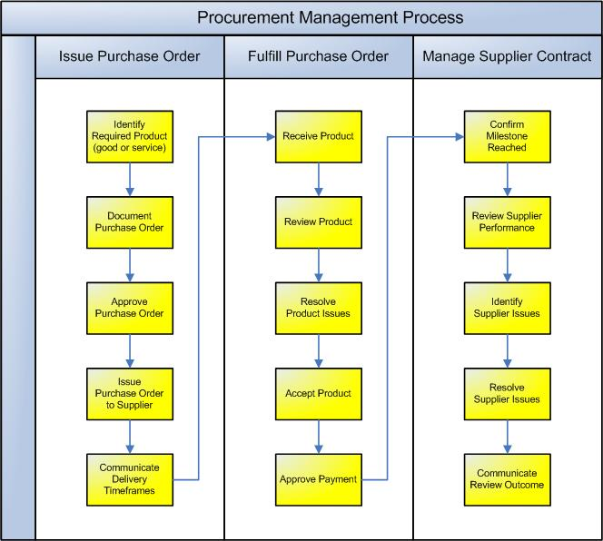

Issue Purchase Order

The first process required to purchase product from an external supplier is the creation and issue of a Purchase Order. The following procedures are undertaken:

    - Identify Required Product
The Procurement Manager (or Officer) identifies the products required to be purchased (and the respective supplier) from the Procurement Plan. S/he also identifies the timeframes within which the products must be delivered and the level of quality each product should adhere to.

    - Document Purchase Order
To request product from an external supplier, the Procurement Manager must complete a ‘Purchase Order’ form. This form defines in detail the specific product required (and its components), the delivery timeframes, the delivery address and the cost center to be charged for the purchase. A Purchase Order form may be completed for several products but only one supplier. It is important that the Purchase Order is completed well before the required delivery date to give the supplier the maximum notice period possible and therefore increase the likelihood of the delivery occurring on time.

    - Approve Purchase Order
The Purchase Order is then forwarded to the Project Manager for approval. The Project Manager will consider the following criteria prior to approving the form:

- Is the product listed within the Procurement Plan?
- Is the product defined in sufficient detail for the supplier to interpret the requirement?
- Is there likely to be sufficient time for the supplier to deliver the product and meet the timeframes outlined within the Procurement Plan?
- Is the supplier listed the approved supplier within the Procurement Plan? ©

    - Issue Purchase Order to Supplier
Once the Purchase Order is approved by the Project Manager, it is issued to the supplier for action (by fax / mail / post).

    - Communicate Delivery Timeframes
The Supplier then confirms receipt of the Purchase Order and issues an ETA (Estimated time of Arrival) for the product. The ETA describes the likely timeframe for delivery of the product to the designated project location.

Fulfill Purchase Order
The Purchase Order is then processed by the supplier and the product delivered to the project as ordered. The Procurement Manager then reviews the product and identifies and resolves any product issues. The product is then formally accepted and supplier payment is authorized. The following procedures are undertaken: ©

    - Receive Product
The supplier fulfils the order by delivering the product (as defined by the Purchase Order) to the Project. The Procurement Manager physically views the product received and confirms that the project team have received it into their care. In the case of a service delivered by the supplier, the Procurement Manager confirms from the project team that the service has been performed and is ready for review.

    - Review Product
The product is then inspected / reviewed to access whether or not it meets the requirements of the initial Purchase Order. This may involve a physical inspection (in the case of a ‘good’) or a series of interviews (in the case of a ‘service’) to determine that the product was delivered on time, within cost and at the level of quality required.

    - Resolve Product Issues
If the outcome of the review is that one or many of the requirements set out by the Purchase Order have not been satisfactorily achieved, then a formal Issue is raised by the Procurement Manager. The extent of the problem is then quantified and the impact and severity of the issue rated. The Project Manager will then lead the resolution of the issue to ensure that it is quickly and appropriately resolved. ©

    - Accept Product
Once all product delivery issues have been resolved, the Project Manager may formally accept the product on behalf of the project team and will notify the supplier.

    - Approve Payment
The supplier will then send the project team an invoice, which is approved for payment by the Project Manager (given no current outstanding issues).

Manage Supplier Contract
The above procedures are undertaken for each Purchase Order issued by the project. In parallel to the procurement of product for the project, the overall performance of the supplier must regularly be assessed to determine that s/he is fulfilling the overall conditions of the contract. This process involves reviewing the supplier's performance and ensuring that all contractual conditions are being met throughout the project.

    - Confirm Milestone Reached
During the Planning phase a number of supplier review milestones will have been identified and documented (as part of the Procurement Plan). Each review milestone may be triggered by the completion of a particular project phase, deliverable or date. Once each milestone is reached, the Procurement Manager informs the Project Manager that the supplier's performance is ready to be assessed and a formal assessment program is initiated. ©

    - Review Supplier Performance
The Procurement Manager leads a review of the supplier's performance. This may involve:
- Confirming that the review milestone has been reached
- Listing the actual products provided by the supplier and identifying whether or not they met the requirements of the purchase order and what impact there was on any delivery issues that arose
- Confirming that each condition listed within the supplier contract was met as specified.

    - Identify Supplier Issues
Any issues identified during the supplier performance review are listed and the overall impact on the ability of the project to achieve its objectives is quantified. A formal supplier issue is then documented and raised with the Project Manager for resolution.

    - Resolve Supplier Issues
The Project manager then leads the resolution of each issue identified through negotiation with the supplier. The following outcomes may occur:

- The supplier is congratulated on his/her performance as there were no supplier issues
- The supplier is informed that should further issues occur, then payment will be withheld and the contract potentially terminated
- Supplier payment is withheld and/or the contract terminated. Legal action may be commenced by either the Project Manager or the Supplier. ©

    - Communicate Review Outcome
Once the supplier performance review is completed and any issues resolved, the outcome of the review is communicated to key project stakeholders (e.g. the Project Sponsor).

Procurement Roles
Define the roles and responsibilities for all resources (both internal and external to the project) involved with the procurement of product and management of supplier relationships. Examples include:

Procurement Manager / Officer
The Procurement Manager (or Officer) is responsible for ensuring that the entire Procurement Management process is executed appropriately, including:

- Identifying the product to be procured from the Procurement Plan
- Documenting each Purchase Order and forwarding it to the Project Manager for approval
- Issuing the Purchase Order and communicating the delivery timeframes
- Receiving and reviewing the product upon arrival at the designated project location
- Identifying and resolving any product delivery issues
- Accepting the product and requesting supplier payment from the Project Manager
- Reviewing the supplier performance and identifying any contractual issues for action. ©

Project Manager
The Project Manager acts as a checkpoint to ensure that the Procurement Management Process is being undertaken properly by:

- Approving each Purchase Order as presented by the Procurement Manager
- Approving each payment as requested by the Procurement Manager
- Resolving supplier contractual issues and agreeing a formal outcome.

Procurement Documents

List any other documentation used to control the purchase of product for the project.

Procurement Register
The ‘Procurement Register’ is the log / database where all Purchase Orders are registered and tracked through to approval. Insert a template for the Procurement Register here to show how Purchase Orders will be monitored for this project (NB Refer to the Method123 ‘Procurement Register’ template for a complete example).

Purchase Order Form
The ‘Purchase Order Form’ is used to request the delivery of product by an external supplier to the project. Insert a template for the Purchase Order Form here to show how Purchase Order will be issued for this project (NB Refer to the Method123 ‘Purchase Order Form’ for a complete example).

